Lexzander Saplan

014177252

CECS 323 - David Brown

**Homework #1**

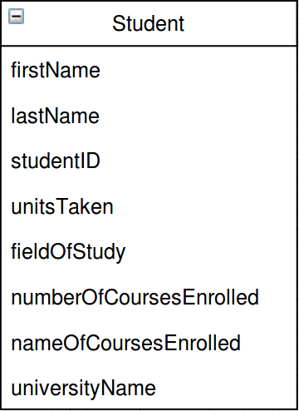

**1) A student at a university**

A person who wants to increase their knowledge in a specific field of study by enrolling at an expensive academic facility that provides the resources and various levels of courses for that person to use as a way of obtaining a future career

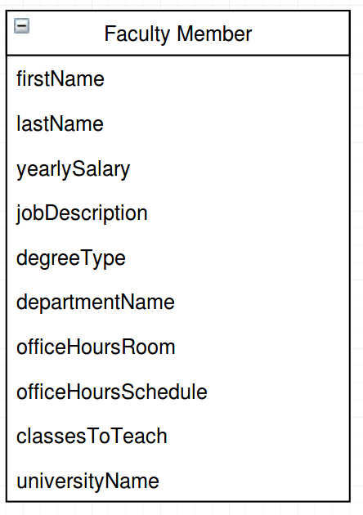

**2) A faculty member at a university**

A person who earns a salary by participating or facilitating in events at an expensive academic institute by either instructing students on academic tasks or even maintaining the safety and infrastructure of the institute

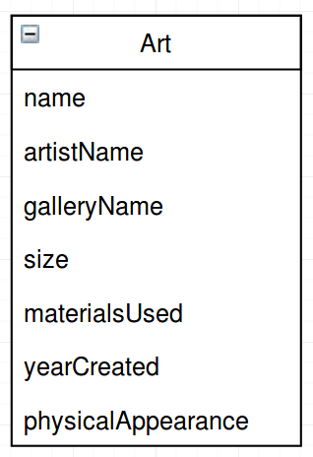

**3) A work of art that is displayed in a gallery or museum**

A physical object of various size, creativity, and emotion developed with a variety of materials that is displayed in a place with similar types of creations originally envisioned by an imaginative person either presently or even historically

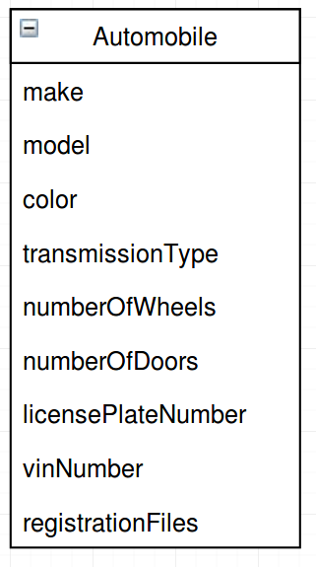

**4) An automobile that is registered with the Motor Vehicle Department**

An automatic mobile type of transportation, recognized by a name and release date, which can be used on any terrain as long as important information about the vehicle, such as it’s identification numbers and proof of existence is, given to the organization that holds all the records about these vehicles

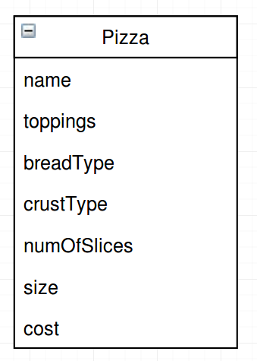

**5) A pizza that is on the menu at a restaurant**

A delicious type of consumable, originating in Italy, composing of a combination of ingredients, such as cheese and various types of meats, layered on top of a circularly, flattened, dough base that is then oven-baked, sliced, and served for a reasonable cost to the consumer where people gather to eat